IAPT - Halton

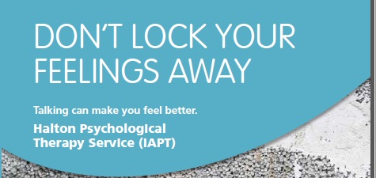
About Us
Who we are & What we do
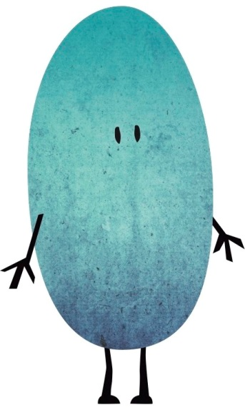
We are Improving Access to Psychological Therapies (IAPT). Our aim is to provide psychological treatments, sometimes called talking treatments, to help people who are stressed, be that feeling low in mood (depressed) or very nervous (anxiety).
The treatments we offer are in line with the NICE guidelines for anxiety and depression.

Our Psychology Service helps patients to:
- Manage and recover from mild to moderate anxiety and depression
- Understand and change currently unhelpful actions and patterns of thinking
Avoid long-term mental health problems

Accessing our services
If you would like to see one of our therapists find our more information here.
If you meet with one of our therapists and it appears that another service might better meet your needs we will make arrangements for you to meet with that service.
Please note, we are a non-urgent service. If you feel that you are in urgent crisis or are worried that you might seriously harm yourself in the near future, please do not complete this form but rather contact your GP or refer yourself to the Mental Health Assessment Team by clicking here
Contact us
Halton Psychological Therapy Service (IAPT)
St John’s Unit
Alforde Street
Widnes
WA8 7QA
Tel: 0151 292 6954
Fax: 0151 292 6951

